



Rotary District 6080

Global Scholarship

Global Scholarship Application Timeline

District 6080 will select one qualified candidate to be recommended to The Rotary Foundation for approval. Once an applicant has been selected by the District Scholarship Committee, he/she will immediately seek admission for graduate study at an institution of choice.
After admission has been obtained, a letter of admission and a proposed course of study must be sent to the Chair of the District Scholarship Committee for submission to The Rotary Foundation, along with the candidate’s application for review and possible approval for funding. Please note that funding is not granted until the candidate’s scholarship application has been approved by The Rotary Foundation.
For further information,
contact Melvin Platt at
mplatt.rotary@gmail.com
573/ 445-3371 (home)
573/ 356-1273 (cell)

- Peace and Conflict Prevention/Resolution
- Water and Sanitation
- Basic Education and Literacy
- Disease Prevention and Treatment
- Maternal and Child Health
- Economic and Community Development

Rotarians recruit scholarship applicants | March through October 23, 2015
Application deadline | October 23, 2015
Clubs interview applicants and make a recommendation | November 3, 2015
District interviews and selects an applicant | November 14, 2015
Scholarship candidate seeks admission at institution of choice | November 15 through February 2016
District submits candidate’s application with letter of admission to the Rotary Foundation for possible approval | No later than March 1, 2016

for 2016-17

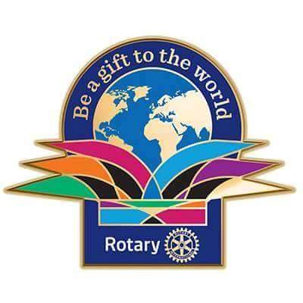


District 6080 will offer one Global Scholarship to a qualified applicant for the 2015-16 academic year. District Designated Funds will be matched by the World Fund of the Rotary Foundation to provide a scholarship award of $30,000.00 to support graduate-level study abroad for one year. That study must focus directly on one or more of the following six focus areas adopted by The Rotary Foundation:
Peace & Conflict Prevention/Resolution
Water and Sanitation
Basic Education and Literacy
Disease Prevention and Treatment
Maternal and Child Health
Economic and Community Development
The Rotary Foundation fully intends these scholarships to have sustainable and high-impact outcomes in these focus areas: http://www.rotary.org/Rldocuments/en_pdf/fv_area_of_focus_policy_statements_en.pdf .

General Scholarship
Highlights & Qualifications

- Applicants must complete a Global Grant Scholarship application, which is available at Rotary6080.org, and submit it to a local Rotary Club where he/she has a legal residency or is his/her place of employment or current college enrollment.
- Scholarship study must take place in a foreign country.

- The scholar must be studying within one of the six areas of focus established by the Rotary Foundation (see above).

- The academic program must be at the graduate level.

- The scholar must demonstrate that he/she has already been accepted for study at the desired university abroad before District 6080 can submit the required Global Grant Scholarship application to The Rotary Foundation for consideration.

- The applicant must complete a district authorized Rotary orientation seminar prior to departure for scholarship study.

- The scholar must begin his/her academic program by the approved 2015 academic date.

- The scholar may NOT be (1) a Rotarian; (2) an employee of a club, district or other Rotary entity, or of Rotary International; (3) the spouse, a lineal descendant (child or grandparent by blood) of any person in the foregoing two categories.

- The scholar must live in the immediate vicinity of the approved study institution in the host district so that he/she can participate in the Rotary club and district activities of the home district.

- Applications must be received by a local Rotary club by October 10, 2014.
EMILY VOSS
Columbia, MO
Global Scholar, 2015-16
London School of Economics
Anthropology & Developmental Studies
JENNA TETER
Fulton, MO
Global Scholar, 2014-15
Australian National University
International Relations

