The District Simplified Grant Application for 2016-2017
District 6080
David Bixler, District Governor

Thank you for your interest in applying for a District Simplified Grant (DSG). These grants are designed to be simple to implement and to report on. The amount of $53,500 will be available for the year 2016-2017 throughout District 6080 for club-directed projects. The DSGs are Single Project Grants with funds available up to and including the amount which each club is eligible based on the attached list. If your club has received an allocation of $1,000 or greater according to the attached list, you may select a single project of your choosing for your DSG in 2016-2017 OR you may elect to participate in the district-wide grant project to benefit Camp Wonderland..

If your club has received an allocation of less than $1,000, District Governor Bixler has an exciting opportunity to share with your club! In 2016-2017, District Governor Bixler has elected to spearhead a district-wide grant project to benefit Camp Wonderland. The amount of $9750 has been set aside to jump start that project.

If your club would like to contribute matching funds and participate in this exciting group project to benefit Camp Wonderland, please email DSG Chair, Melissa Davis and your club will be added to the group list.

Please refer to the attached Terms and Conditions for Rotary Foundation District 6080 District Simplified Grants which our District agrees to follow when implementing the grants. Please read carefully “Eligibility Guidelines” to verify that your project meets the criteria for a District Simplified Grant. Also, please review the attached Rotary District 6080 Grants Guidelines for District Simplified Grants 2016-2017. If you have questions, please contact Melissa Davis (contact information below).

The deadline for this application is May 15, 2016. Late applications will NOT be accepted.

Applications should be mailed, faxed, or emailed to Melissa Davis.

Melissa Davis
ATTN: Rotary District Simplified Grant Chair
The Library Station
2535 North Kansas Expressway
Springfield, MO 65803

WORK PHONE # 417-616-0682
FAX # 417-862-6514
melissad@thelibrary.org

1. List the name(s) of the club(s) to be involved in the project:

2. What is the estimated start date? (Project must begin after August 04, 2016).

3 . What is the estimated completion date? (Project must end by March 01, 2017.) Please note the Final Reporting date for all projects is April 15, 2017.

4. Describe the project, its location, and its objectives.

5. Describe how the project will benefit the community and/or improve the lives of the less fortunate.

6. Describe the non-financial participation by Rotarians in the project.

7. Please provide details regarding the publicity of this project (i.e. Newspaper articles, television).

8. Cooperating organizations-If the project involves a cooperating organization, please provide the name of the organization below and attach a letter of participation from that organization that specifically states its responsibilities and how Rotarians will interact with the organization in the project. By signing this application, the Rotarian sponsors endorse the organization as reputable, responsible, registered with the project country, and acting within the laws of the project country. (Be sure cooperating organizations understand that we require copies of all financial documentation in connection with the project.)

9. Budget – please include a complete, detailed, and itemized budget for both income and expenses for the entire project. Supporting documentation utilized for the development of this budget may be requested.

10. Please describe any conflict of Interest, either actual or perceived, that exists with this project and any Rotarians in your Club. (Refer to Chapter 2 - Programs, Article 10 - General Program Policies, Section 10.030 - Conflict of Interest Policy for Program Participants in the ROTARY FOUNDATION CODE OF POLICIES dated April 2016. This document is attached to this application form.)

10. Authorization – The Rotary Club involved in this project is responsible to Rotary District 6080 for the conduct of the project and for reporting on it. The signature on this application confirms that the sponsors understand and accept the responsibility. The signature of the sponsor also affirms that all information in this application is true and accurate, to the best of their knowledge. The signature of the sponsor confirms that they have read and agree to Terms and Conditions for Rotary Foundation District 6080 – District Simplified Grants (For Grants awarded After July 1, 2016) and Rotary District 6080 Grants Guidelines – District Simplified Grants for Rotary Year 2016-2017.

Project contacts: Two Rotarians must be listed who will provide oversight and management of the project funds and who will provide progress reports annually or when the project is completed.

Primary contact information:

Name_______________________________________

Rotary position/title ___________________________

Address_____________________________________

____________________________________________

Evening Phone________________________________
Daytime Phone________________________________

Fax_________________________________________

Email_______________________________________

Secondary contact information:

Name_______________________________________

Rotary position/title ___________________________

Address_____________________________________

____________________________________________

Evening Phone________________________________
Daytime Phone________________________________

Fax_________________________________________
Email_______________________________________

Club President – As President of the Rotary Club of _______________________________________________________________________, I hereby affirm that the club has voted to undertake this project as an activity of the club.

_______________________________________
Name (please print)

________________________________________ ___________________
Signature Date

District Use Only

Approved / Not Approved

District Simplified Grants Chair

District Simplified Grant Allocations for 2016-2017
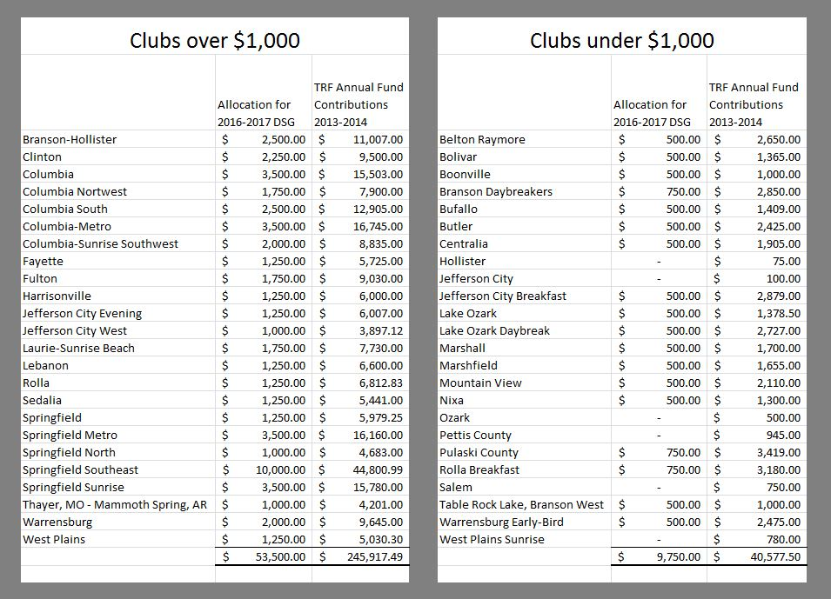
Rotary Foundation Code of Policies, April 2016

10.030. Conflict of Interest Policy for Program Participants
All individuals involved in a program grant and/or award shall conduct their activities in a way that avoids any actual or perceived conflict of interest. A conflict of interest is a relationship among individuals through which an individual involved in a program grant or award causes benefit, or could be perceived to cause benefit, for such individual or such individual’s family, personal acquaintances, business colleagues, business interests, or an organization in which such individual is a trustee, director, or officer. This conflict of interest policy shall be applied in the following circumstances as specifically set forth below. The application of this conflict of interest policy shall not be limited to these circumstances.

1. Award Recipient Eligibility
Pursuant to section 9.3 of the TRF bylaws, those individuals defined below shall not be candidates or final award recipients or beneficiaries of any TRF program. Such individuals shall include current Rotarians; employees of clubs, districts, and other Rotary Entities (as defined in the Rotary Code of Policies) or of Rotary International; spouses, lineal descendants (children or grandchildren by blood, legal adoption, or marriage without adoption), spouses of lineal descendants or ancestors (parents or grandparents by blood) of persons in the foregoing categories; and employees of agencies, organizations, or institutions partnering with TRF or RI.

Former Rotarians shall continue to be ineligible for a period of 36 months after termination of their membership. Persons who were ineligible based on their familial relationship to a former Rotarian shall continue to be ineligible for a period of 36 months after termination of their family member’s membership. Notwithstanding the foregoing, such individuals shall be eligible to participate on vocational training teams and in individual travel for humanitarian projects (when such individuals are determined to be qualified) funded by district grants, global grants, and packaged grants.

2. Impartiality of Selection Committees Rotarians who serve on a club or district-level selection committee for a TRF program are expected to exercise complete transparency in their familiar, personal, or business relationship with an applicant and must notify the committee chair in advance of the selection process of any actual or perceived conflict of interest due to the committee member’s association with a TRF program award candidate, e.g. employees of the same firm or organization, members of the same Rotary club or member of the same club sponsoring an application, familial relationship, etc.

The selection committee chair will decide how and if that committee member should participate in the selection process for that one or all candidates with whom there is an actual or perceived Rotary Foundation Code of Policies 77 April 2016 conflict of interest. If the selection committee chair is the individual with an actual or perceived conflict of interest, the club board or the DRFC chair, as appropriate, will decide how and if such chair should participate in the selection process for that one or all candidates with whom there is an actual or perceived conflict of interest.

3. Business Transactions with Vendors
Before TRF, a Rotary district, a Rotary club, or a Rotarian conducts business transactions related to a TRF program award in which the vendor receives payment from a Rotary Entity, a fair, open and thorough request for proposals or bidding process must be conducted to ensure that the best services are secured at a reasonable cost, despite any connection between a vendor and a Rotary Entity. Possible conflicts of interest may arise when a Rotary Entity is considering business in which funds will be paid to a Rotarian; a goods and/or services provider owned or managed by a Rotarian, Honorary Rotarian, employee of a club, district, or other Rotary Entity or of Rotary International, Rotarian’s spouse, lineal descendants (child or grandchild by blood, legal adoption, or marriage without adoption), spouses of lineal descendants, and ancestors (parent or grandparent by blood), or employees of agencies, organizations, or institutions partnering with TRF.

Examples of business relationships that may require further review to confirm that a Rotarian conflict of interest does not exist include business transactions with a partner nongovernmental organization, goods or services provider, insurance company, travel agency, shipping agency. study institution, language skills testing firm, etc.

Business transactions with individuals or entities with whom there is an actual or perceived conflict of interest can be completed upon approval of the general secretary if such transaction provides the best product or service at fair market value, as evidenced by a sales quote or offer obtained through a fair, open and thorough request for proposals or bidding process.

The general secretary shall provide advise on how to interpret and implement this conflict of interest policy. Any unresolved conflict of interest involving a program grant or award must be reported by a Rotarian or Rotary entity involved to the general secretary at least 30 days in advance of the selection process or proposed business transaction. The general secretary will decide if a conflict of interest may exist for a particular case. If, upon review of the situation, the general secretary concludes that there is or has been a conflict of interest in the execution of a TRF program grant or award, the general secretary shall fashion an appropriate remedy. Such remedy may include the cancellation of current or suspension of future TRF program grants or awards involving a particular Rotary, Rotary club or Rotary district. (October 2014 Trustees Mtg., Dec. 53)

Source: November 1983 Board Mtg., Bd. Dec. 166; May 1988 Trustees Mtg., Dec. 127; March 1992 Trustees Mtg., Dec. 114; June 1994 Trustees Mtg., Dec. 165; October 2006 Trustees Mtg., Dec. 55 Amended by June 2010 Trustees Mtg., Dec. 139; April 2011 Trustees Mtg., Dec. 93; April 2013 Trustees Mtg., Dec. 104; October 2014 Trustees Mtg., Dec. 53

