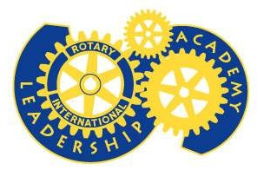

Light Up Rotary!!

Be part of Rotary's Future

Enroll in the

District Leadership Academy

Inaugural Class of 2015



On September 1, Rotary District 6080 will launch the **District Leadership   
Academy Program**. The Leadership Academy is a 7-month online Rotary education program which trains Rotarians to serve as leaders at the Club and District level. It is often referred to as “Rotary Graduate School”. Well trained club and district leaders, means we will have strong and effective Rotary clubs.

This year, Rotarians in District 6080 can **“Light Up Rotary”** in their clubs by participating in the Leadership Academy program. Applications for admission to the 2014-2015 Academy along with a wealth of informational materials about the DLA are now available for downloaded from the new   
**District 6080 Leadership Academy web site** at  
[**http://www.academy6080.org**](http://www.academy6080.org).

**The application deadline is August 20. 2014**.

Submit your application along with the other required documents for   
admission **to PDG Raymond Plue** via email to [**plue-r@socket.net**](mailto:plue-r@socket.net)

Enroll Today